31. bodyless package

Create table:

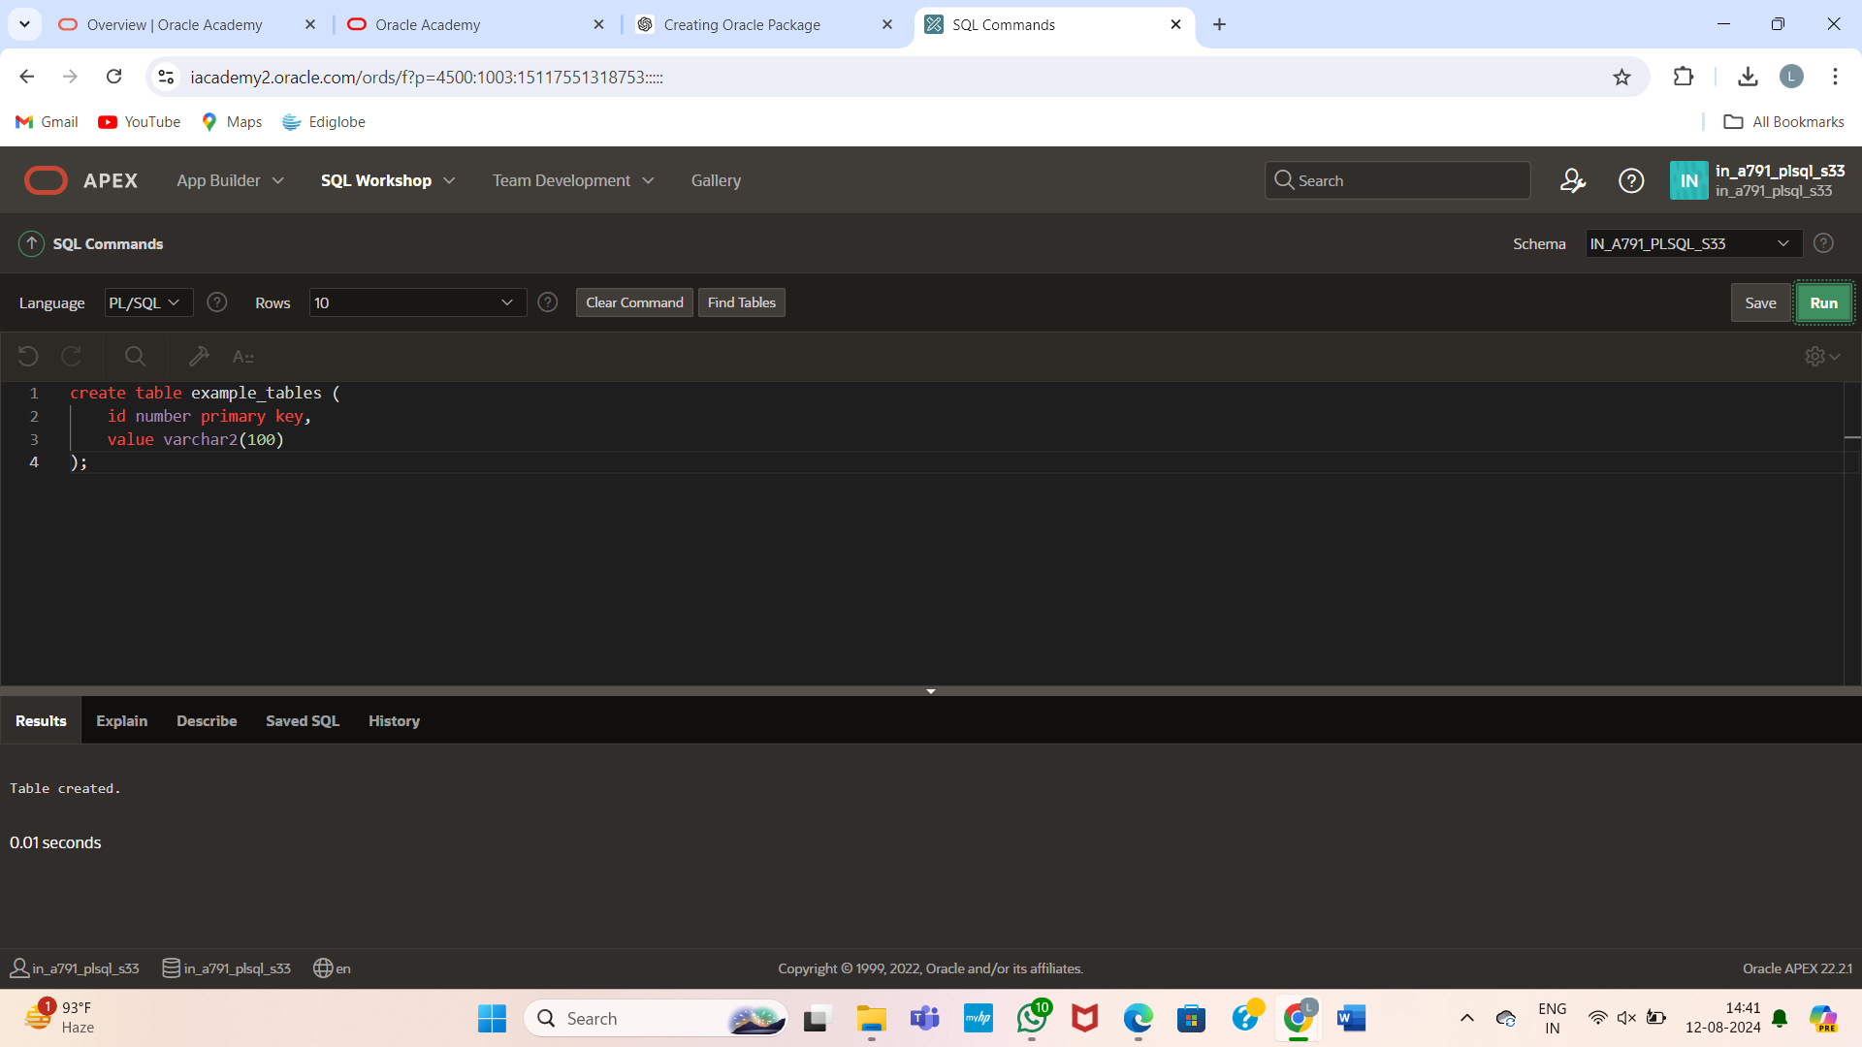

CREATE OR REPLACE PACKAGE our_exceptions IS e_cons_violation EXCEPTION; PRAGMA EXCEPTION_INIT (e_cons_violation, -2292); e_value_too_large EXCEPTION; PRAGMA EXCEPTION_INIT (e_value_too_large, -1438); END our_exceptions;

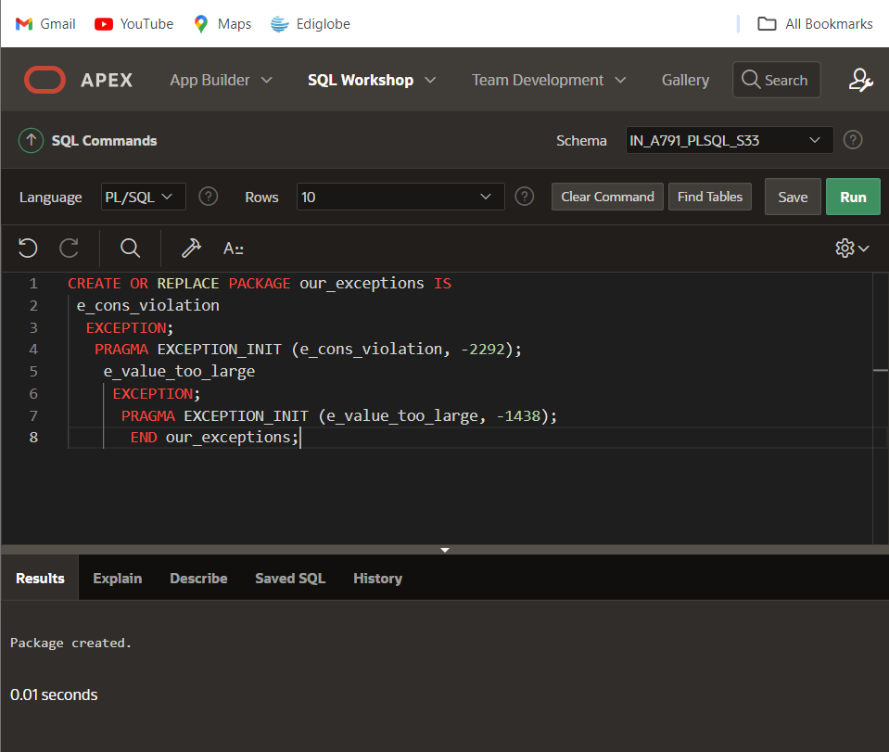

GRANT EXECUTE ON our_exceptions TO PUBLIC;

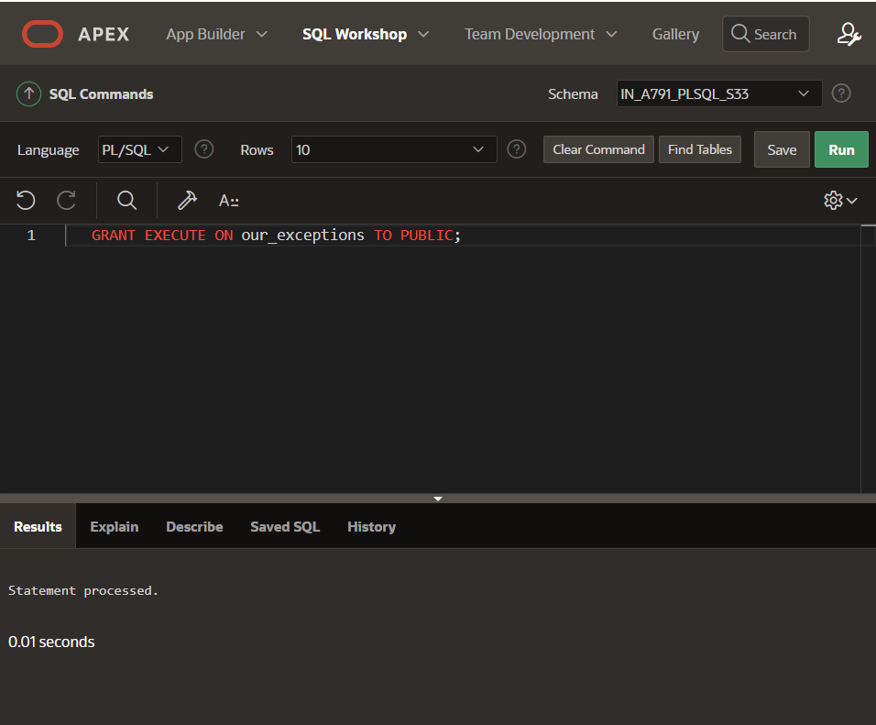

CREATE OR REPLACE PACKAGE global_consts IS mile_to_kilo CONSTANT NUMBER := 1.6093; kilo_to_mile yard_to_meter meter_to_yard CONSTANT NUMBER := 0.6214; CONSTANT NUMBER := 0.9144; CONSTANT NUMBER := 1.0936; END global_consts;

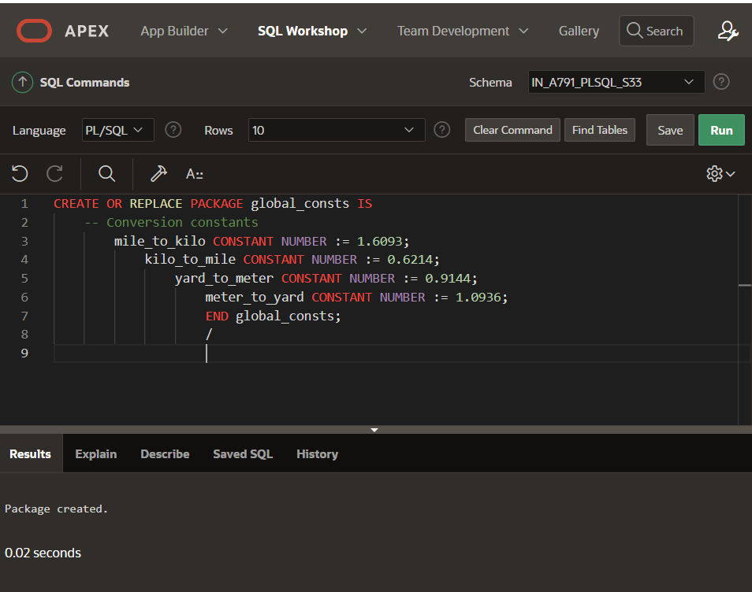

GRANT EXECUTE ON global_consts TO PUBLIC;

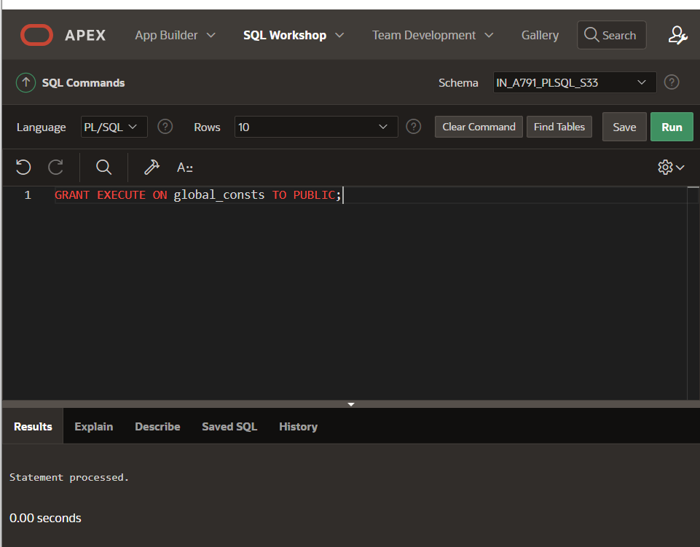

DECLARE distance_in_miles NUMBER(5) := 5000; distance_in_kilo NUMBER(6,2); BEGIN distance_in_kilo := distance_in_miles * global_consts.mile_to_kilo; DBMS_OUTPUT.PUT_LINE(distance_in_kilo); END;

